# useEffect- Proper use

Source :- [All useEffect Mistakes Every Junior React Developer Makes](https://youtu.be/QQYeipc_cik)

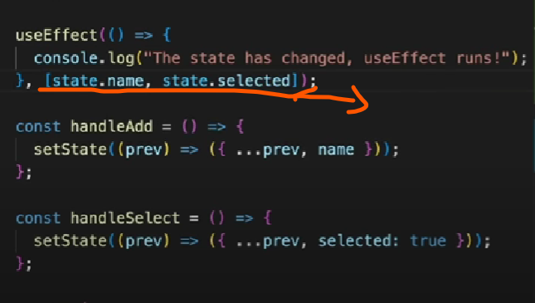

The above image is showing that to put dependency array properly for ex ➖

Var user [{

Name:”test”,

selected:true

}];

If you want to execute useEffect only when one of the key value change then instead of

[user] do ➖ [user.name,user.selected];

Becoz [1] ===[1] = false;

2) Clean up function

Clean up function will always run first after initial render then useEffect.

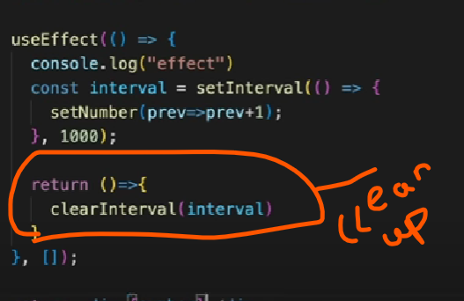

2) Clean-up while fetching - with normal js

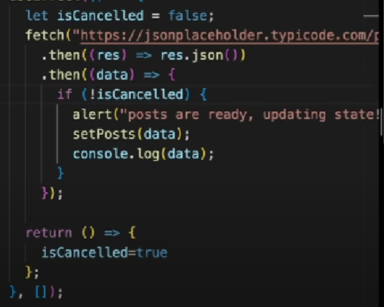

3) with advance js technique

useEffect(() => {

const controller = new AbortController();

const signal = controller.signal;

const fetchUser = *async* () => {

const response = await fetch(`/api/users/${userId}`, { signal });

const data = await response.json();

setUser(data);

setLoading(false);

};

fetchUser();

return () => {

controller.abort();

};

}, [userId]);